A07- xxxxxxx UX Design

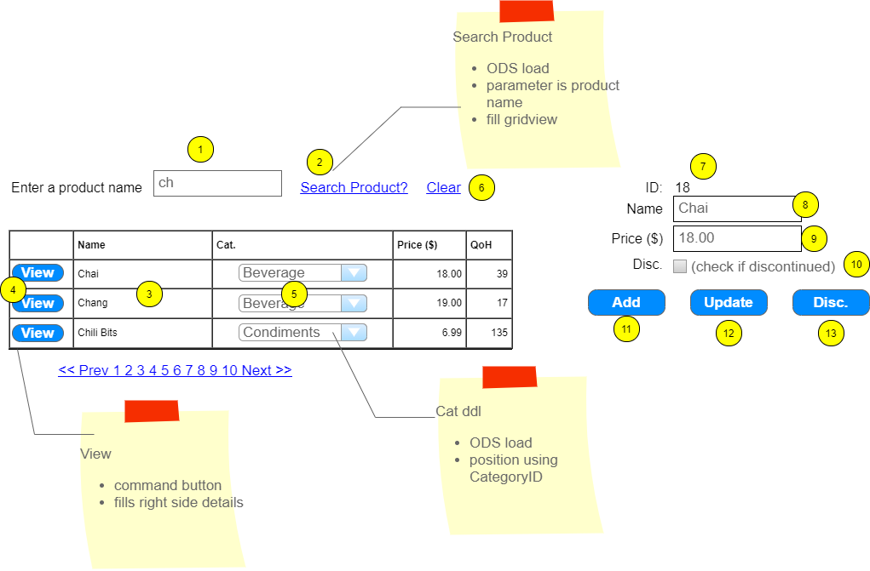

|  |  |  |  |  |  |
| --- | --- | --- | --- | --- | --- |
|  | Controls | Load/Usage | CRUD | Validation | Event actions / Notes |
| 1 | ProductArg | -/2 | R | presence |  |
| 2 | SearchProduct | 1/3 | R |  | Fires ODS for Gridview fill  **List<Product> Product_FindByPartialName(string)** |
| 3 | ProductList | 3/4 | R |  | hidden field on row for argument id  category is ddl/ODS, customize, paging |
| 4 | Select Command button | -/7-10 | R |  | Collection hidden field  **Product Product_FindByID(int)**  Fill product details |
| 5 |  |  |  |  |  |
| 6 |  |  |  |  |  |
| 7 |  |  |  |  |  |
| 8 | ProductName | 4/11,12 | CU | Presence |  |
| 9 |  |  |  |  |  |
| 10 |  |  |  |  |  |
| 11 | Add | -/8-10 | C |  | Collection input values  Load an instance of Product  **Int Product_Add(Product)**  Return new product id  Refresh ID (7) |
| 12 | Update | -/7-10 | U |  | Collection input values  Load an instance of Product  **Int Product_Update (Product)**  Return row affected  Appropriate message |
| 13 |  |  |  |  |  |